Integration Instance with ORM Stack

Contents

1. Introduction 3
2. Workflow diagram to deploy the stack 4
3. Create stack for the Integration Instance “Default Domain” 5
4. Plan the Job 6
5. Apply the Job 8
6. Verify in the Console 9
7. Destroy the stack 10

Introduction

In Oracle Cloud Infrastructure (OCI), an Integration Instance is a fully managed, serverless platform for integrating applications and services within your OCI environment or between OCI and external systems. It enables you to build, deploy, and manage integrations using a graphical user interface (UI) and pre-built adapters.

Key features of Integration Instance in OCI include:

Adapters: Integration Instance provides a rich set of pre-built adapters that allow you to connect to various systems and services, such as databases, file servers, messaging systems, and cloud applications.

Orchestration: You can define complex integration flows by orchestrating the execution of various actions and transformations using a visual designer. This enables you to automate business processes and data flows across different systems.

Monitoring and Logging: Integration Instance offers monitoring capabilities to track the performance and health of your integrations. You can monitor metrics, set up alerts, and view logs to troubleshoot issues and optimize performance.

Security: Integration Instance integrates with Oracle Identity and Access Management (IAM), allowing you to manage access to integrations using IAM policies. It also supports secure connectivity options, such as virtual cloud networks (VCNs) and private endpoints.

Scalability and Resilience: Integration Instance automatically scales to handle high volumes of integration traffic. It provides built-in fault tolerance and resiliency features, ensuring that your integrations are highly available.

Developer Tools: OCI offers a range of developer tools, including a web-based UI for designing and configuring integrations, a command-line interface (CLI) for automation and scripting, and APIs for programmatic access and integration with other OCI services.

Workflow diagram to deploy the stack
Below diagram shows how the Terraform Artifact are applied in the OCI. While creating a ORM stack, using terraform deliverables Init, Plan and Apply is the flow to provision the resource in the OCI. We can have the deliverables in any of below.
- GitLab/GitHub Repo
- Bitbucket
- Can be in folder/.zip in the local disk
- Object Storage Bucket
- Can be in compartment
- Oracle provided Template


Create stack for the Integration Instance “Default Domain”

Go to OCI Console Developer Services Resource Manager Stacks select the compartment Create Stack

My Configuration Folder Browse Select the “Integration Instance” folder that contains the terraform Upload

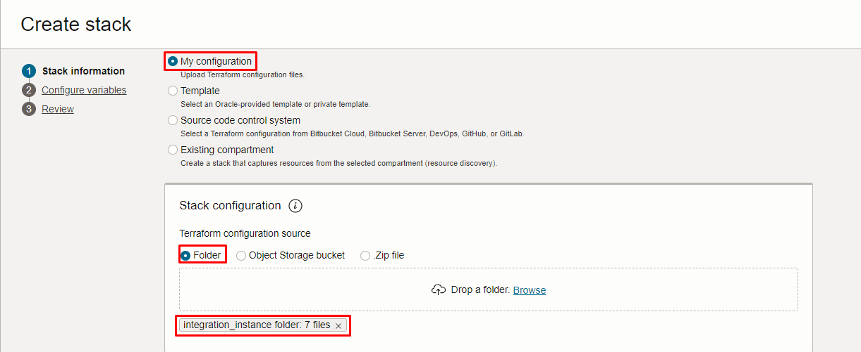

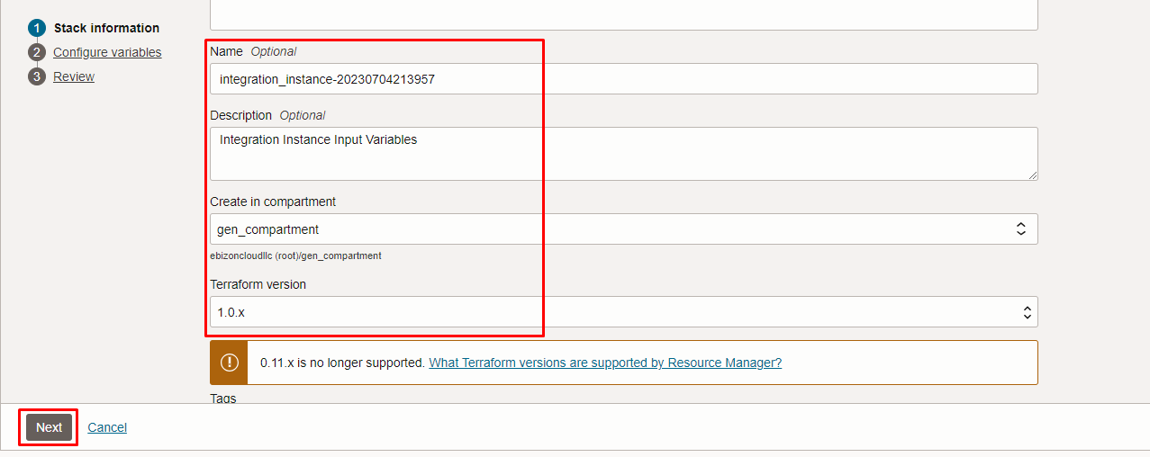

Click “NEXT”

Select the parameters as per the below screen,

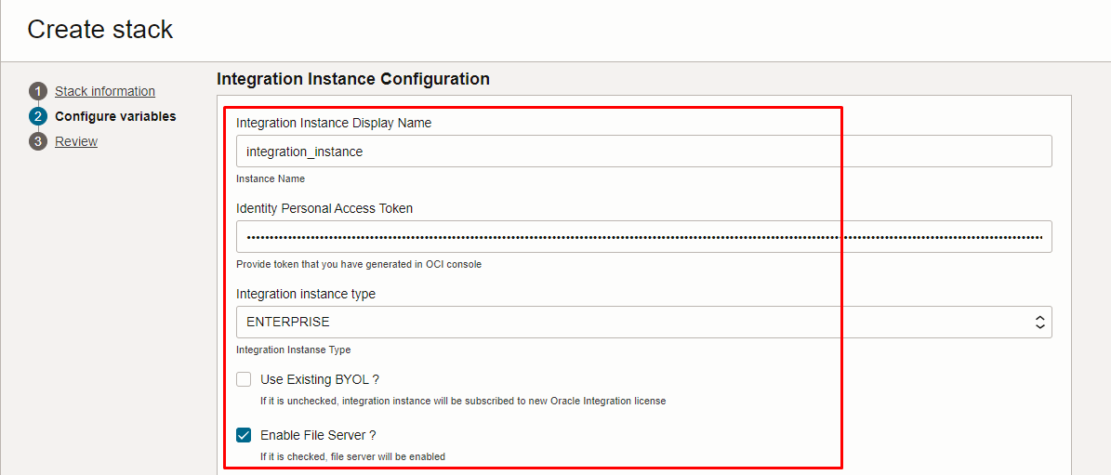
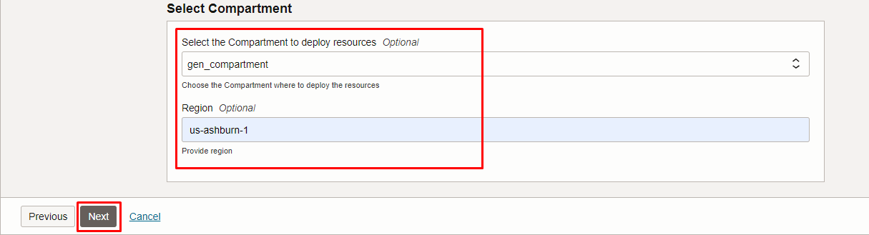

Click “NEXT” Click “CREATE”

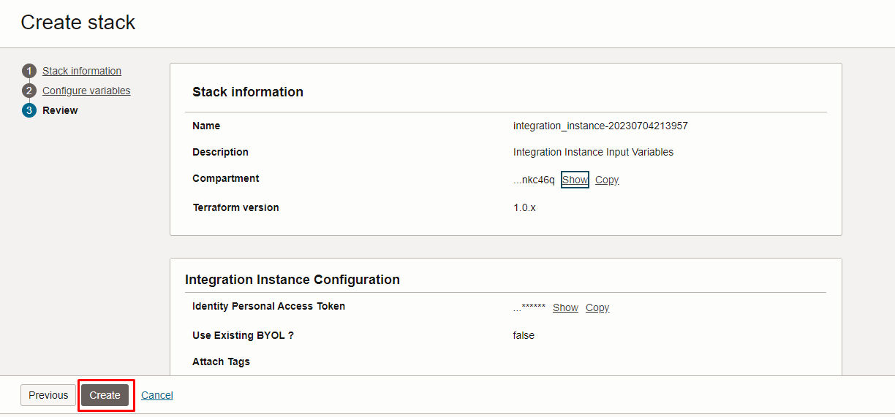

Plan the Job

Click the “Plan”

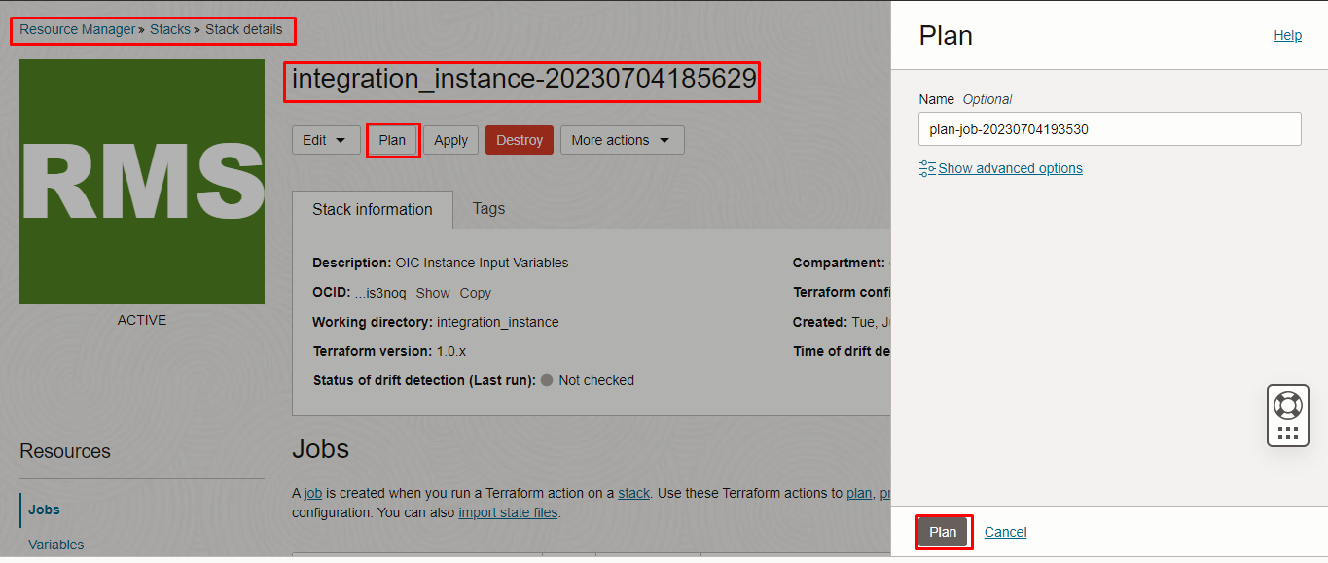

Verify the Plan is successful.

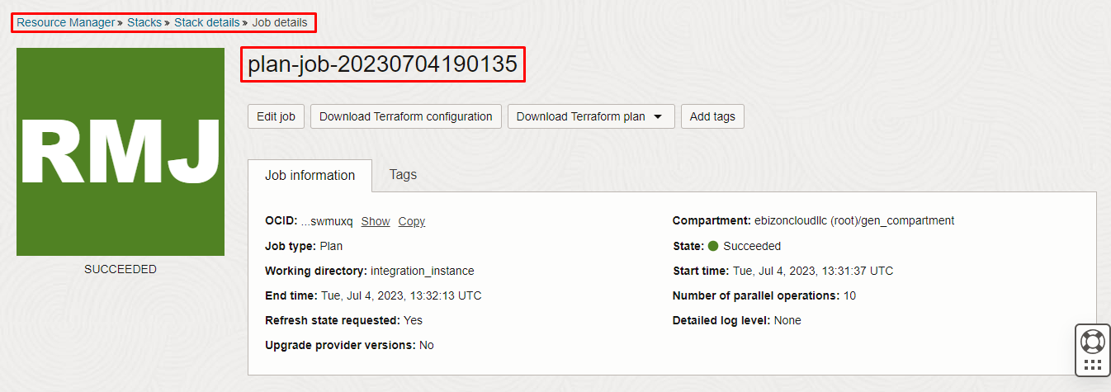
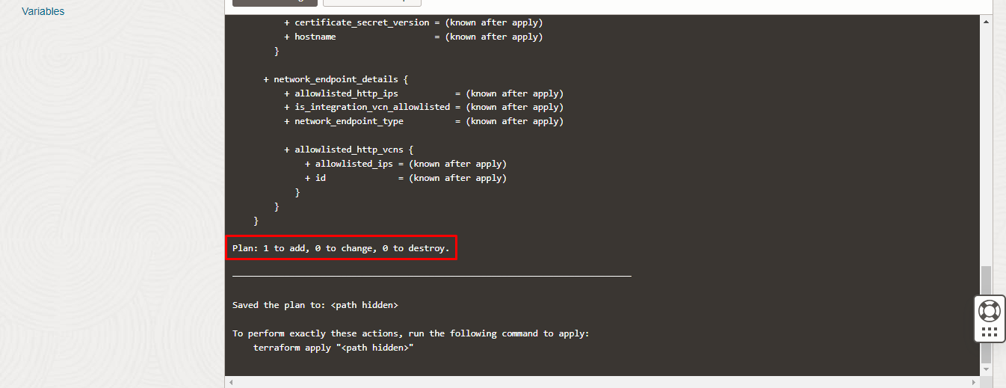

Apply the Job

Once the “plan” is success, now click “Apply”

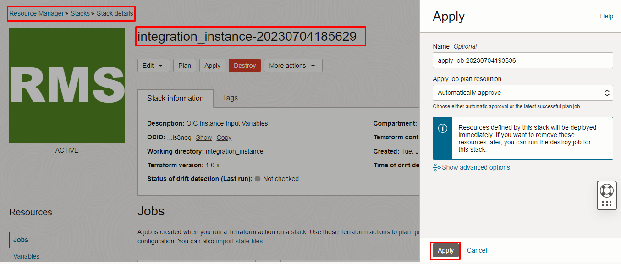
Verify the Apply is successful.
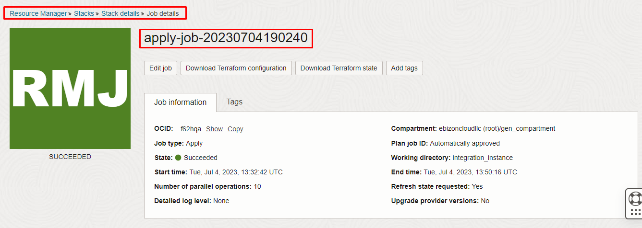
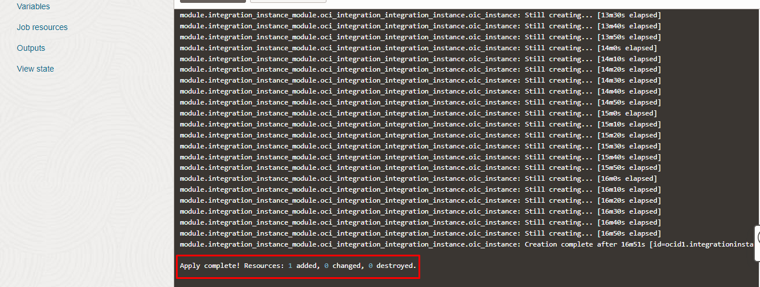

Verify in the Console

Go to OCI Console Application Integration Integration Instance

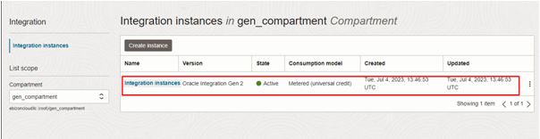
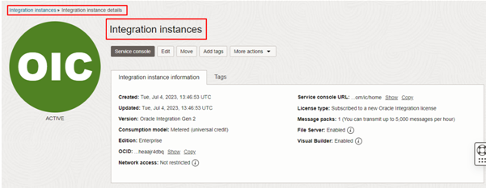

Destroy the stack

Create a destroy job in Resource Manager to release resources associated with a stack and clean up the tenancy. Once destroyed data cannot be recovered from resources.

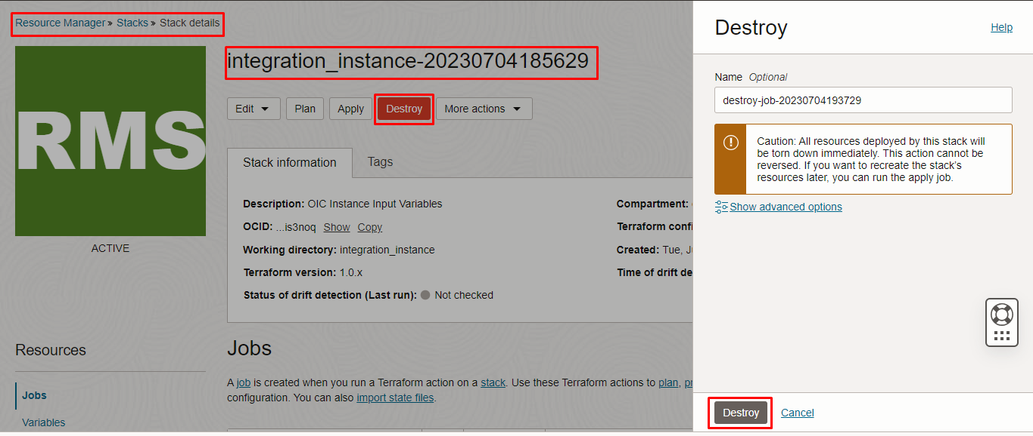

#####END#####

